EC Declaration of Conformity
according to EC TOY´s Directive 2009/48/EC

We herewith declare, NSH NORDIC A/S, Virkefeltet 4, DK-8740 Brædstrup, Denmark

That the following described TOY in our delivered version complies with the appropriate basic safety and health requirement of the EC TOY Directive 2009/48/EC based on its design and type, as brought into circulation by us.

Description of the safety component Sandbox with foldable seat and cover
Art. no.: 805-701

Safety Function : Outdoor toy for children from 3-10 years

Applicable EC Directives EC Toy Directive 2009/48/EC

Applicable Harmonized Standards EN 71-1:2015

Applicable National Technical
Standards and None
Specifications

.
Certificate: TüV Z1 16 02 56915 007
Test report: TüV 713078347-1

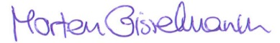

Date/Authorized Signature: …………………………….
Time of signatory Brædstrup, the 1st of March 2016

Archives
............................
Safety component.-No.

